**Laborator 2**

**Exemplu:**

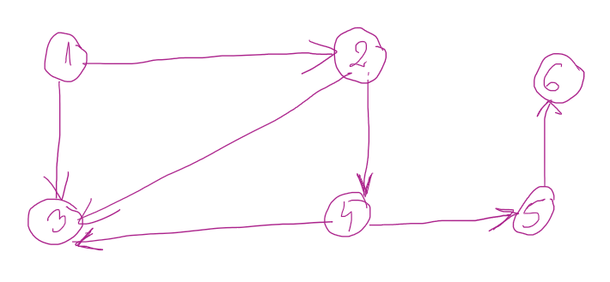

**matricea inchiderii tranzitive**

t(i, j) = 1, daca exista drum intre (i, j)

0, daca nu exista drum intre (i, j)

|  |  |  |  |  |  |  |
| --- | --- | --- | --- | --- | --- | --- |
|  | 1 | 2 | 3 | 4 | 5 | 6 |
| 1 | 0 | 1 | 1 | 1 | 1 | 1 |
| 2 | 0 | 0 | 1 | 1 | 1 | 1 |
| 3 | 0 | 0 | 0 | 0 | 0 | 0 |
| 4 | 0 | 0 | 1 | 0 | 1 | 1 |
| 5 | 0 | 0 | 0 | 0 | 0 | 1 |
| 6 | 0 | 0 | 0 | 0 | 0 | 0 |

pseudocod:

for (k = 1; k <= n; k++)

for (i = 1; i <= n; i++)

for (j = 1; j <= n; j++)

if (t[i][j] == 0)

t[i][j] = (t[i][k] && t[k][j]);

**algoritmul lui Moore – slide 39**

drum minim intre 2 noduri:

nod start 1

nod final 6

* 1 2 4 5 6

distante:

|  |  |  |  |  |  |
| --- | --- | --- | --- | --- | --- |
| 1 | 1 | 1 | 1 | 1 | 1 |
| 1 | 2 | 3 | 4 | 5 | 6 |
| 0 | 1 | 1 | 2 | 3 | 4 |

La final, in directorul de aici

<https://ubbcluj-my.sharepoint.com/:f:/g/personal/adriana_coroiu_ubbcluj_ro/Em4URjojuhxPvaoXNYdVYAIBiYVkI_leVX8DVtLxecJVpw?e=dsuyFR>

incarcati solutiile (doar cpp) cu numarul laboratorului si nr problemei: ex. L2p2